SIMATS ENGINEERING (SAVEETHA SCHOOL OF ENGINEERING)
Department of Artificial Intelligence and Data Science

ASSESSMENT TOOL 2 – Case Study

Course Code: | DSA03 | Course Title: | Natural Language Processing
CO Assessed: | CO3 – Precision | Assessment: | Assessment Tool 2 – Case Study
Weightage: | 30% of CIA
CO5 Statement: | Apply N-gram models, smoothing techniques, part-of-speech tagging systems and to evaluate effective syntactic analysis. (BL-3)
Student Name: | I. Leela Sravan Kumar | Reg. No.: | 192425272
Section / Batch: |  | Date:

Code of Conduct
I I. Leela Sravan Kumar (192425272) (Name / Reg No) certify that this submission is my original work and that I have adhered to the guidelines specified for this assessment. I understand that any violation of academic integrity rules will result in disciplinary action.
Signature of the Student: I. Leela Sravan Kumar

Instructions
- Read all three case studies carefully before attempting the questions.
- Provide appropriate justifications and interpretations for every computed result.
- Use NLP concepts, algorithms, and terminology wherever applicable.
- Diagrams, flowcharts, tables, or mathematical formulations may be used to support your answers.
- Duration: 30 minutes.

Section / Topic | Focus | Case Study
N-Gram Language Models and Smoothing Techniques | Bigram and Trigram probability computation, Maximum Likelihood Estimation (MLE), Backoff models, Deleted Interpolation, Entropy calculation, uncertainty analysis, real-time next-word prediction | Case Study 1 – Smart  Mobile Keyboard  Prediction System
Part-of-Speech (POS)  Tagging and Word Classes | Penn Treebank tagset, contextual ambiguity resolution, rule-based tagging, stochastic tagging (HMM), emission and transition probabilities, word class identification, chatbot language understanding | Case Study 2 – AIPowered Customer Support Chatbot
Transformation-Based Tagging (Brill Tagger) | POS tag correction, transformation rules, contextual tagging, linguistic validation, tag sequence refinement, ambiguity handling | Case Study 3 – News  Analytics and POS Tag Correction System
Corpus Statistics and  Probabilistic Analysis | Word frequency counting, corpus-based probability estimation, entropy-based uncertainty  measurement, tagging confidence evaluation | Case Study 3 – News  Analytics and POS Tag Correction System
Integrated Syntactic  Analysis and NLP  Applications | Application of language models, POS tagging, probabilistic methods, corpus analysis, ambiguity resolution, and decision-making in real-world NLP systems | Case Studies 1, 2, and 3

Annexure A – Case Study

CASE STUDY 1: E-Commerce Smart Search and Product Prediction System
An e-commerce company is developing an AI-powered search and autocomplete system that predicts the next word when customers enter product-related queries. The language model is trained on the corpus:
"machine learning improves business, machine learning enables automation, machine learning drives innovation."
The development team uses Bigram and Trigram Language Models, Backoff Models, Deleted Interpolation, and Entropy Analysis to improve search prediction and handle unseen word sequences.
The following statistics are obtained from the corpus:
- C(machine) = 3
- C(machine learning) = 3
- C(learning improves) = 1
- C(learning enables) = 1
- C(learning drives) = 1
- C(learning improves business) = 1
The interpolation weights are:
- λ₁ = 0.5 (Trigram)
- λ₂ = 0.3 (Bigram)
- λ₃ = 0.2 (Unigram)
The prediction probabilities after the word "learning" are:
- P(improves) = 0.33
- P(enables) = 0.33
- P(drives) = 0.33
Questions
- Compute the Maximum Likelihood Estimate (MLE) of the Bigram Probability P(learning | machine). Interpret how this probability can influence the next-word prediction of an ecommerce search system.
- A customer enters the unseen sequence "machine learning transforms". Apply the Backoff Model and estimate the probability of the word "transforms" using lower-order N-grams. Explain why backoff is useful when customers enter previously unseen search queries.
- Using Deleted Interpolation, calculate the probability of the sequence "machine learning improves" using the given interpolation weights. Explain how combining trigram, bigram, and unigram probabilities improves robustness when training data is sparse.
- Calculate the Entropy of the prediction distribution P(improves) = 0.33, P(enables) = 0.33, P(drives) = 0.33. Interpret the entropy value and explain what it indicates about uncertainty in the search prediction system.
- Develop a Python program using NLTK for N-gram generation, NumPy for probability computations, and the Math library for entropy calculation. The program should construct Unigram, Bigram, and Trigram models from the given corpus, compute the MLE Bigram probability, estimate an unseen sequence using Backoff, calculate the Deleted Interpolation probability using the given weights, compute entropy of the prediction distribution, and display all intermediate calculations and the final next-word prediction in a structured format.
1. MLE of Bigram Probability
Given:
C(machine, learning) = 3
C(machine) = 3
Formula:
P(learning | machine) = C(machine, learning) / C(machine)
Calculation:
P(learning | machine) = 3 / 3
= 1.0
Interpretation:
The probability of learning occurring after machine is 1.0 (100%). Therefore, the search system can strongly predict learning as the next word after machine.

2. Backoff Model for "machine learning transforms"
The customer enters:
machine learning transforms The trigram is:
(machine, learning, transforms)
This trigram does not occur in the training corpus.
Step 1 – Trigram:
P(transforms | machine, learning) = 0 because C(machine, learning, transforms) = 0.
Step 2 – Bigram:
P(transforms | learning) = 0
because C(learning, transforms) = 0.
Step 3 – Unigram: P(transforms) = 0 because transforms does not occur in the corpus.
Final Backoff Probability:
P(transforms | machine, learning) = 0
Interpretation:
Backoff is useful because it allows the system to use lower-order N-grams when a higherorder N-gram is unseen. In this particular case, even the unigram is unseen, so the final probability remains 0.

3. Deleted Interpolation
Given weights: λ1 = 0.5 (Trigram) λ2 = 0.3 (Bigram) λ3 = 0.2 (Unigram)
For the sequence: machine learning improves
Trigram Probability
C(machine, learning, improves) = 1
C(machine, learning) = 3
P(improves | machine, learning) = 1 / 3
= 0.3333
Bigram Probability
C(learning, improves) = 1
C(learning) = 3
P(improves | learning) = 1 / 3
= 0.3333
Unigram Probability
Total number of words = 12
C(improves) = 1
P(improves) = 1 / 12
= 0.0833
Interpolation Formula
P(improves | machine, learning) = λ1 × P(improves | machine, learning)
- λ2 × P(improves | learning)
- λ3 × P(improves)
Calculation
= (0.5 × 0.3333) + (0.3 × 0.3333) + (0.2 × 0.0833)
= 0.1667 + 0.1000 + 0.0167
= 0.2834
Final Answer: 0.2833 approximately
Interpretation:
Deleted Interpolation combines trigram, bigram, and unigram probabilities. Therefore, the model remains more robust when higher-order N-grams are sparse or unavailable.

  - Entropy of Prediction Distribution
Given:
P(improves) = 0.33
P(enables) = 0.33
P(drives) = 0.33
Entropy Formula: H = -Σ P(x) log2 P(x)
Calculation:
H = -[0.33 log2(0.33) + 0.33 log2(0.33) + 0.33 log2(0.33)]
H = -[3 × 0.33 × log2(0.33)]
H ≈ 1.58 bits
Interpretation:
The entropy is approximately 1.58 bits, which is close to the maximum entropy for three possible outcomes. Since all three words have almost equal probabilities, the system has high uncertainty about which word will occur next.

  - Python Program
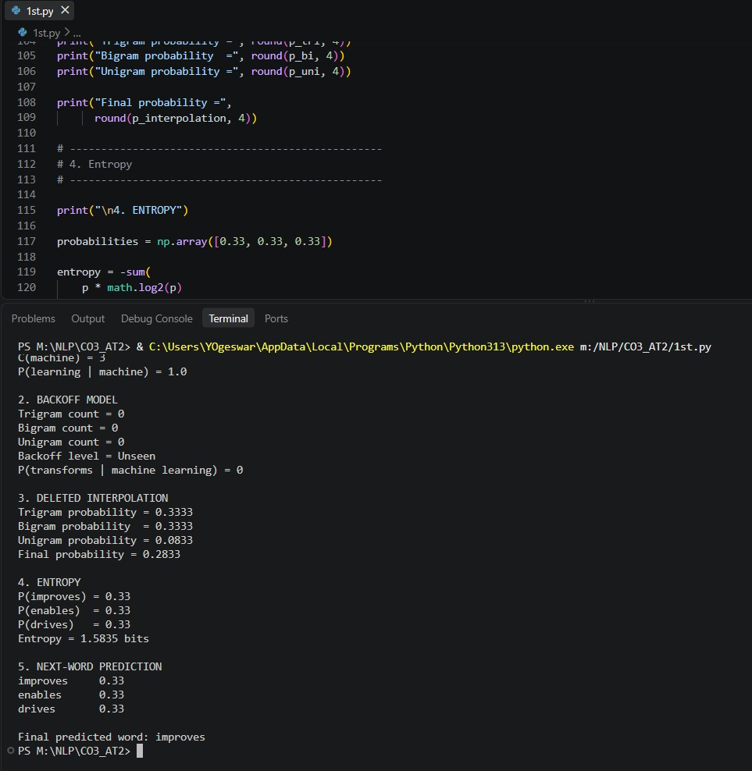

CASE STUDY 2: AI-Powered Hospital Appointment Chatbot
A healthcare organization develops an AI-powered chatbot that assists patients in booking appointments. The chatbot performs Part-of-Speech tagging before identifying user intentions and generating responses.
Consider the following user inputs:
  - "Book an appointment with the doctor."
  - "The book contains medical information."
The chatbot uses the Penn Treebank POS Tagset and an HMM-based probabilistic POS tagger to determine the grammatical role of ambiguous words.
For the word "book", the system is given:
- P(book | VB) = 0.7
- P(book | NN) = 0.3
- P(Start → VB) = 0.6
- P(Start → NN) = 0.4
The system must determine whether "book" functions as a Verb (VB) or Noun (NN) depending on its context.
Questions
- Assign appropriate Penn Treebank POS tags to every word in both sentences. Justify the POS tag assigned to "book" using the grammatical context of each sentence.
- Using the given HMM probabilities, compute the likelihood of "book" being tagged as a Verb (VB) and as a Noun (NN). Determine the most probable tag and explain why the probabilistic model favors that tag at the beginning of a sentence.
- Compare Rule-Based POS Tagging and Stochastic HMM Tagging for resolving the ambiguity of the word "book". Discuss the advantages and limitations of both approaches in a healthcare chatbot.
- Evaluate how standardized POS tagsets such as the Penn Treebank Tagset can support downstream NLP tasks such as intent detection, entity identification, and response generation in healthcare chatbots.
- Develop a Python program using NLTK to tokenize the given sentences and assign Penn Treebank POS tags. Implement a simple HMM-based POS tagging calculation using the given emission and transition probabilities. The program should calculate the probability of "book" being tagged as VB and NN, determine the most likely tag, display the tokenized sentences, POS-tagged output, intermediate probability calculations, and final tagging results in a structured format.
- Sentence:-
Word | POS Tag
Book | VB
an | DT
Word POS Tag
appointment NN
with IN
the DT
doctor NN
. .
- Sentence:-
Word POS Tag
The DT book NN contains VBZ medical JJ information NN
. .

2. HMM Probability Calculation
Probability of "book" as Verb
Given:
P(book | VB) = 0.7 P(Start → VB) = 0.6
Formula:
P(VB, book) = P(book | VB) × P(Start → VB)
Calculation:
= 0.7 × 0.6
= 0.42
Probability of "book" as Noun
Given:
P(book | NN) = 0.3
P(Start → NN) = 0.4
Calculation:
= 0.3 × 0.4
= 0.12
Comparison
VB probability = 0.42 NN probability = 0.12
Since:
0.42 > 0.12
Most probable tag = VB
Interpretation:
At the beginning of a sentence, the given HMM probabilities favor VB because the combined emission and transition probability for VB is higher than that for NN.

- Rule-Based POS Tagging vs Stochastic HMM Tagging
Rule-Based POS Tagging Advantages:
  - Simple to understand.
  - Easy to implement.
  - Rules are transparent.
  - Works well for known grammatical patterns.
Limitations:
  - Requires manually created rules.
  - Difficult to handle complex language.
  - May fail when context changes. Stochastic HMM Tagging Advantages:
  - Uses probabilities.
  - Can use contextual information.
  - Can resolve ambiguity statistically.
  - Suitable for large amounts of text.
Limitations:
  - Requires training data.
  - Performance depends on probability estimates.
  - May struggle with unseen words and contexts.
Conclusion:
For a healthcare chatbot, combining grammatical rules with probabilistic context can provide more reliable POS tagging.

- Importance of Penn Treebank POS Tags
Standardized POS tags provide consistent grammatical information to NLP systems.
Intent Detection
POS tags can help identify actions such as:
  - Book → VB
  - appointment → NN
This helps identify an appointment-booking intent.
Entity Identification
POS information can help distinguish nouns that may represent entities such as:
  - doctor
  - hospital
  - appointment
  - medicine
Response Generation
POS tags help the chatbot understand the grammatical structure of the user's request and generate an appropriate response.
Conclusion:
A standardized tagset improves consistency between POS tagging and downstream NLP tasks.

5. Python Program
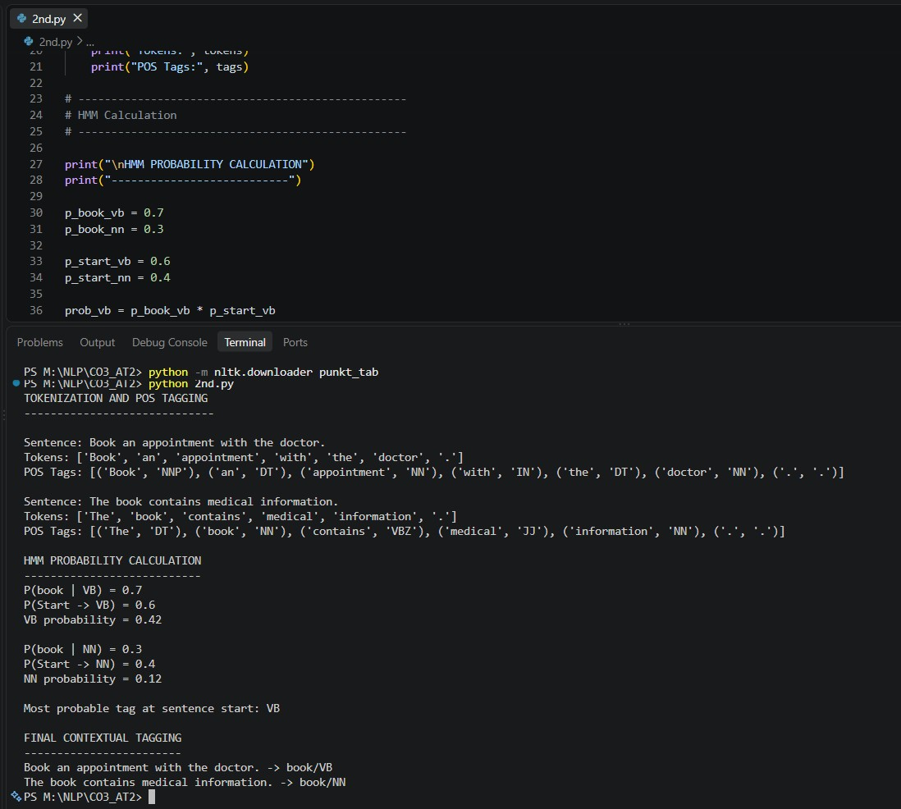
CASE STUDY 3: Financial News POS Tag Correction and Uncertainty Analysis
A financial news analytics company processes thousands of financial news articles every day. The system initially assigns POS tags using a statistical POS tagger and subsequently applies a Transformation-Based Tagger (Brill Tagger) to correct common tagging errors.
The sentence processed by the system is:
"Market growth drives investment."
The initial POS tags produced by the system are:
- market/NN
- growth/NN
- drives/NNS
- investment/NN
A learned transformation rule states:
Change NNS to VBZ if the preceding word is tagged as NN.
The system also performs corpus-based frequency analysis and entropy-based uncertainty evaluation.
The corpus contains the following word frequencies:
- market – 500 occurrences
- growth – 350 occurrences
- drives – 180 occurrences
- investment – 420 occurrences
Questions
- Apply the given transformation rule to the initial POS-tag sequence. Display the corrected POS-tag sequence and explain why the transformation is linguistically appropriate.
- Analyze the initial tagging error for "drives". Explain why the word should receive the VBZ tag in this sentence and discuss how the surrounding grammatical context helps identify the correct tag.
- Using the given corpus statistics, calculate the relative frequency/probability of each word. Explain how corpus frequency information can support probabilistic POS tagging and language processing.
- Calculate the entropy of the word-frequency distribution before and after applying the transformation rule. Explain what entropy indicates about uncertainty in the tagging or prediction process.
- Develop a Python program using NLTK for initial POS tagging and implement a simple Transformation-Based Tagger that applies the rule "Change NNS to VBZ if the preceding word is tagged as NN." The program should tokenize the sentence, generate initial POS tags, apply the transformation rule, calculate word-frequency probabilities from the given corpus statistics, calculate entropy using the Python math library, and display the initial tags, corrected tags, frequency distribution, entropy values, and final POS-tagging results in a structured format.

Applying the Transformation Rule
Initial POS tags:
market/NN growth/NN drives/NNS investment/NN
Transformation Rule:
Change NNS to VBZ if the preceding word is tagged as NN.
The word before drives is: growth/NN
drives
The current tag of is:
drives/NNS
Therefore, the rule applies. Corrected POS sequence:
market/NN growth/NN drives/VBZ investment/NN Final sentence:
market/NN growth/NN drives/VBZ investment/NN
Interpretation:
market growth
The transformation is linguistically appropriate because forms a singular noun
phrase and | drives | functions as the main singular present-tense verb.

Error Analysis of drives
The initial tag was:
drives/NNS
NNS means plural noun.
However, in:
Market growth drives investment.
market growth |  | is the subject.  is the main verb describing the action performed by the subject.
drives
Therefore, the correct tag is:
drives/VBZ
VBZ represents a third-person singular present-tense verb.
The surrounding context helps identify that |  |  | drives | is functioning as a verb rather than a noun.

Relative Frequency / Probability
Given frequencies:
C(market) = 500
C(growth) = 350
C(drives) = 180 C(investment) = 420
Total frequency:
Total = 500 + 350 + 180 + 420
= 1450
Market
P(market) = 500 / 1450
= 0.3448
Growth
P(growth) = 350 / 1450
= 0.2414
Drives
P(drives) = 180 / 1450
= 0.1241
Investment
P(investment) = 420 / 1450
= 0.2897
Final Distribution: market = 0.3448 growth = 0.2414 drives = 0.1241 investment = 0.2897 Interpretation:
Corpus frequency provides statistical information about how commonly words occur. A probabilistic POS tagger can use such frequency information along with contextual and transition probabilities to make better tagging decisions.

Entropy of Word-Frequency Distribution
Entropy Formula:
H = -Sum P(x) × log2(P(x)) Using the probabilities:
H = -[(0.3448 × log2(0.3448)) + (0.2414 × log2(0.2414)) + (0.1241 × log2(0.1241)) + (0.2897 × log2(0.2897))]
H = 1.9161 bits
Before Transformation
Entropy = 1.9161 bits
After Transformation
The transformation only changes the POS tag of the word frequencies. | drives | from NNS to VBZ. It does not change
Therefore:
Entropy = 1.9161 bits
Final Answer:
Entropy before transformation = 1.9161 bits
Entropy after transformation = 1.9161 bits
Interpretation:
Entropy measures the uncertainty in the word-frequency distribution. The entropy does not change because the transformation changes only the POS tag and not the word-frequency values. The transformation improves the POS-tagging accuracy, but it does not change the given frequency distribution.

5. Python Program
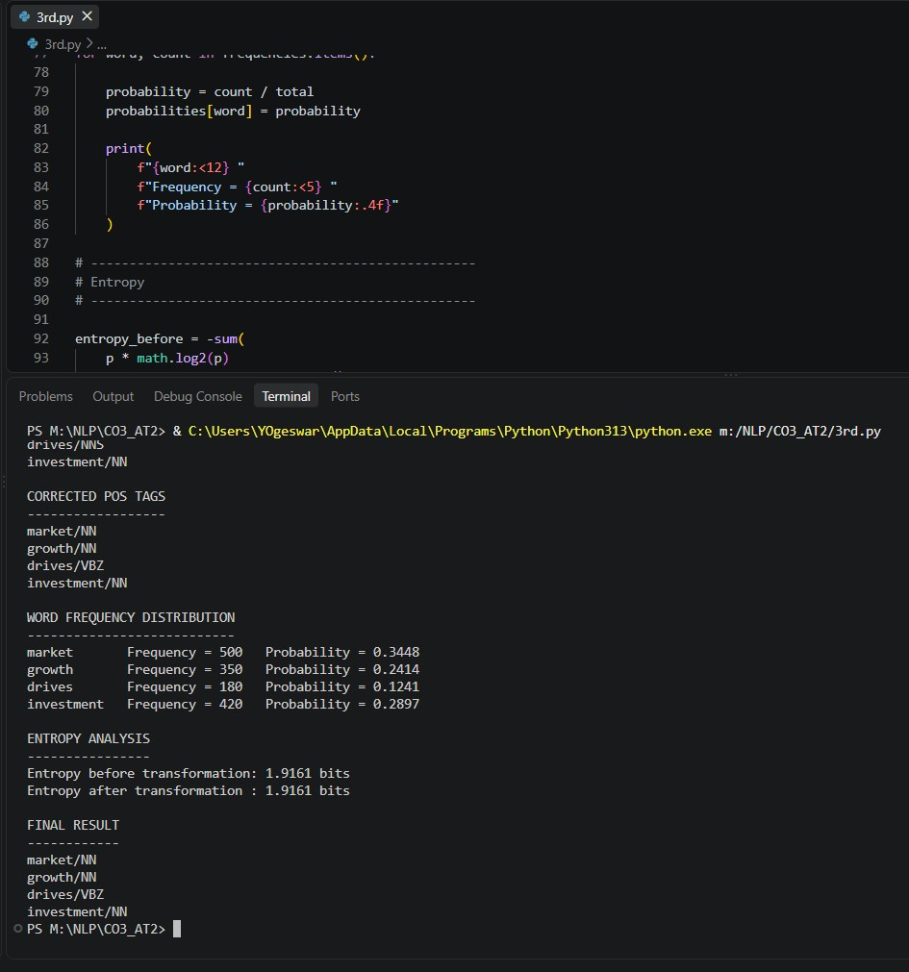

Rubrics for Calculation

Criteria | Weightage | Level 4 –  Exemplary | Level 3 –  Proficient | Level 2 –  Developing | Level 1 –  Beginning
Understa nding of  Case | 25 | Thorough understanding;  clearly identifies all key issues | Good understanding  with most issues identified | Basic understanding; some issues missed | Poor understanding;  problem not identified correctly
Applicati on of  Concepts | 25 | Effectively applies relevant concepts to  analyze the case deeply | Applies appropriate  concepts with minor gaps | Limited application of concepts | Fails to apply relevant concepts
Analysis | 20 | In-depth analysis with strong  reasoning and insights | Good analysis with logical reasoning | Basic analysis with limited depth | Weak or no analysis; lacks reasoning
Solution Design | 20 | Innovative, feasible solutions with strong justification | Logical solutions with adequate justification | Basic solutions with weak justification | Incorrect or no solution provided
Clarity | 10 | Clear, wellstructured, and easy to understand | Organized and understandable presentation | Limited clarity and structure | Poor clarity; difficult to  understand

Q. No. /  Criteria  Level | Understanding of Case | Application of Concepts | Analysis | Solution Design | Clarity | Sub.  Total | Total %
1 | 3 | 3 | 4 | 3 | 3 | 16 | 78
2 | 3 | 3 | 4 | 3 | 3 | 16
3 | 3 | 3 | 4 | 3 | 3 | 16
4 | 3 | 3 | 4 | 3 | 3 | 16
5 | 3 | 3 | 4 | 3 | 3 | 16

Faculty In-charge | Course Coordinator | Program Director
KUMARAGURUBARAN. T
Signature: _______________ | Signature: _______________ | Signature: _______________
Date: ___________________ | Date: ___________________ | Date: ___________________

